**Protocol for Wizard of Oz study using humanoid NAO in “An Intelligent Prompting System to Help Teach Self-Care Skills to Children with Autism Spectrum Disorder”**

**Summary**

**Background:** Autism Spectrum Disorder (ASD) is recognised as the most common neurological disorder affecting children. The problems that these chidren encounter while learning self-care can lead to dependence and frustration for both the child and their family. The Intelligent Assistive Technology and Systems Lab (IATSL) has built a device that uses artificial intelligence to monitor and prompt children with ASD through the representative activity of handwashing. However, engagement and compliance issues were identified as areas of improvement. To this end, we investigate the possibility of using a humanoid robot, NAO, as a prompting agent for COACH to better engage the child during hand-washing. It is hoped that the use of embodied humanoids will increase the task performance of children with ASD, and will eventually help them to learn how to complete a variety of activities of daily living (ADL), thereby helping them to become more independent. In addition, the device could be of great value to caregivers and family members by augmenting the assistance they provide for their children, thus helping to relieve caregiver burden.

**Purpose:** The overall goal of this research is to determine if the humanoid robot is an appropriate prompting agent in the COACH system, and if it is able to promote engagement, compliance, and performance of children with ASD in the hand-washing tasks.

**Methods:** This research study will be conducted using a Wizard of Oz design and will take place in the HomeLab washroom at Toronto Rehabilitation Institute (TRI). Each child with his/her parent will be asked to come to the HomeLab once a week with a total of six visits. The child will be asked to wash his/her hands eight times for each visit. The child will be asked to wash his/her hands as independently as possible (baseline phase) for his/her first two visits. For the other four visits the child will be assisted by either the robot or the virtual avatar displayed on the Liquid-Crystal Display (LCD) screen. Both the robot and the avatar will be remotely controlled by the student researcher from another room. The impacts of the robotic embodiment against the avatar will be compared to the child’s engagement, compliance, and task performance. The effects of the help from both the robot and the virtual avatar will also be compared with the child’s hand-washing level in the baseline phase.

**Significance:** The results of this study will provide valuable information about the usability of a humanoid robot as a prompting agent for children with ASD. This study is an initial but crucial step towards an automated socially assistive robot in teaching children with ASD self-care skills while reducing caregiver burden.

# Introduction

Autism Spectrum Disorder (ASD) is a complex neurological condition. It is estimated that one in 150 children have ASD and this figure is on the rise [1].One of the most significant concerns of parents of children with ASD is whether their child will live a safe, productive, and independent life. Independent living starts with competence in functional behaviours such as self-care, which many children with ASD have difficulties completing independently. Children with ASD require extensive support and assistance with activities from their families and/or other caregivers and they may continue to require this care throughout their adult life [2]. The associated time, effort, and responsibility can cause considerable burden for those caring for an individual with ASD [2, 3].

The ability to independently complete self-care tasks is an important milestone in child development, significantly improving sense of competence, lowering frustration and decreasing behavioural outbursts, which are a major issue impacting on the individual’s and family’s quality of life. It has been shown that early, specific, and intensive interventions can help many children with ASD learn the skills they will need to lead independent lives [4]. These interventions make use of various prompting strategies, which are used to initiate, maintain, or terminate an activity. Prompt types that have proven to be effective include tactile, auditory/vocal, gestural, written, pictorial, and video prompts [5, 6]. While these prompting strategies may be effective, they demand much effort and diligence from a caregiver to set-up, initiate use, and to teach the child.

One way to meet the needs of individuals with ASD while reducing strain on caregivers is to use technology to create novel interventions. The COACH (**C**ognitive **O**rthosis for **A**ssisting with a**C**tivites in the **H**ome) system, developed by Mihailidis et al., is an autonomous prompting system [7]. It uses computer vision and artificial intelligence to automatically detect user actions when performing ADLs, and prompts appropriately when user needs assistance. It was first developed for the dementia population, but a version appropriate to the ASD population was recently adapted and tested in a pilot study [8].

In this pilot study, the system used audio and video prompts through a Liquid-Crystal Display (LCD) screen as its primary prompting modalities. The hand-washing activity was used as an example to test the system’s effectiveness because of the simplicity of its tasks as well as the washroom settings being easily controlled. The hand-washing activity was broken down into five tasks, with verbal prompts being: “turn on the water and wet your hands”, “put soap on your hands”, “scrub your hands”, “rinse your hands”, and “turn off the water and dry your hands”. At the beginning of each task, an Attention Grabber (AG) was issued by displaying a still image on the LCD screen. Then, a Prompt was issued by displaying pre-recorded audio and/or video on the LCD screen. If the child did not complete the task successfully following the prompt, either the prompt would be repeated or the caregiver would be called for assistance. If the child completed the task successfully, a Reward would be issued by playing a pre-recorded audio (i.e. “Good job!”) on the speaker [8].

This pilot study of COACH for ASD showed good task performance – 78% of the hand-washing steps were completed by the child with ASD without caregiver assistance [8]. However, there were limitations in the system’s performance. The major area of improvement identified in the study was to increase child’s engagement during activity and compliance to prompts. Almost half of the system’s prompts were ignored, which mainly was because the children weren’t paying attention to the prompts or were not interested in the tasks (as observed during the trial or reported by the parents). A primary goal of this new project is to address these limitations through a pilot study that will explore the role of robotics in this type of prompting system.

Studies have shown that children with ASD respond particularly well to humanoid robots – they are more engaged when facilitated by these robots during the activities studied [9-11]. Therefore, this pilot study will explore the use of the socially assistive humanoid robot as a prompting agent to help children with ASD wash their hands. Specifically, we want to determine if the robot will promote a better engagement, compliance, and task performance compared to the prompts given from a virtual avatar that’s displayed on the LCD screen. We also want to explore if the use of the prompting agents (i.e. the robot and the virtual avatar) can help the children wash their hands more independently compare to their baseline phase when they wash their hands by themselves without any help provided from the robot or the virtual avatar.

# Study Objectives

The objectives for this study are to:

1. Explore different modes of interactions between the robot and the children,
2. Evaluate the effects of robotic embodiment on children’s engagement, compliance, and task performance,
3. Gauge the attitude of the child and his/her parent towards the robot as a prompting agent during hand-washing activity,
4. Collect gaze data in order to develop and evaluate an automatic gaze estimation algorithm for detecting the child’s level of engagement and attention, including where the child is looking during the task and which objects he/she is interacting with.

Specifically, we will explore the attitudes of both the child and the parent about the use of the robot as a prompting agent for hand-washing through surveys. Also, we will determine the effects of the robot on the engagement of the child during the hand-washing by measuring the percentage of time the child is looking at the correct object (i.e. the robot or the LCD screen during prompting and the sink objects during the task performance), the percentage of the compliance to prompts, and the number of times the child is distracted from the tasks. It is hypothesized that the child will be more engaged when prompted by the robot than in their baseline phase (i.e. washing his/her hands without any help from the prompting agents) as well as when prompted by the virtual avatar on the LCD screen. Lastly, we will determine the effects of the robot on the hand-washing performance of the child by measuring the number of tasks successfully completed without the assistance from his/her parent. It is hypothesized that the child will complete more tasks successfully when prompted by the robot than in the baseline phase and when prompted by the virtual avatar.

The information gathered in this study will then be used to inform future developments of the prompting system, possibly leading to clinical trials of the automated version of the system.

# Study Outline

### Method

Study Setup

The study will be conducted in the washroom of Toronto Rehabilitation Institute’s (TRI) HomeLab.

The equipment will be set up near the sink, which includes a NAO robot, an LCD screen with a speaker, a mini-sized computer, an overhead camera, a scene camera, and a Kinect camera. The NAO robot is a small half-torso humanoid robot and will be placed on the sink countertop close to the LCD screen (please see Figure 1(a)). The NAO robot will deliver verbal and gesture prompts to the children with ASD while they are performing the hand-washing tasks. The LCD screen will be mounted on the wall beside the sink mirror. The LCD screen will display a virtual avatar, which is a pre-recorded video version of the NAO robot (please see Figure 1(b)). The virtual avatar on the LCD screen will deliver the same prompts as the NAO robot. This is to compare the effects of embodiment in prompting agents. The mini-sized computer will be tucked behind the LCD screen.

The overhead camera will be installed on the wall/mirror right above the sink. The overhead camera will record objects on the sink countertop (e.g., taps, faucet, soap, and towel). The purpose of the overhead camera is to capture the hand actions of the child during hand-washing in order to track the child’s progress along the tasks. The scene camera will be placed on the floor with its field of view including all objects in the scene (e.g., LCD screen, robot, child, and objects on sink countertop). The purpose of the scene camera is to capture the child’s engagement and attention during the prompts as well as during task executions. The Kinect camera will be placed on the sink countertop besides the LCD screen. The Kinect camera will record mainly the child’s face. The purpose of the Kinect camera is to capture the depth information of the child’s face for the development of an automatic algorithm that estimates the child’s gaze direction in real-time. Examples of the images captured by the three cameras are shown in Figure 2.

b)

a)

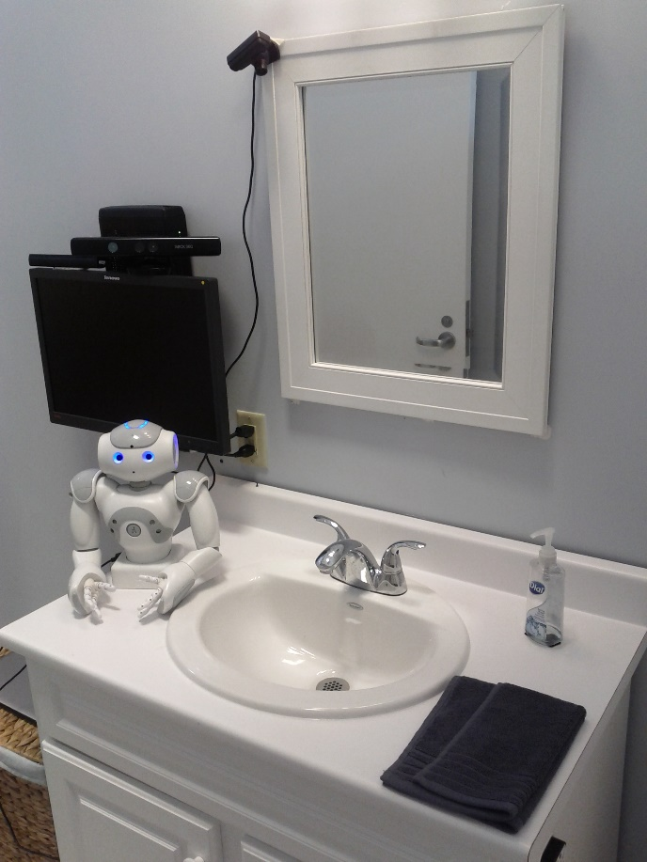 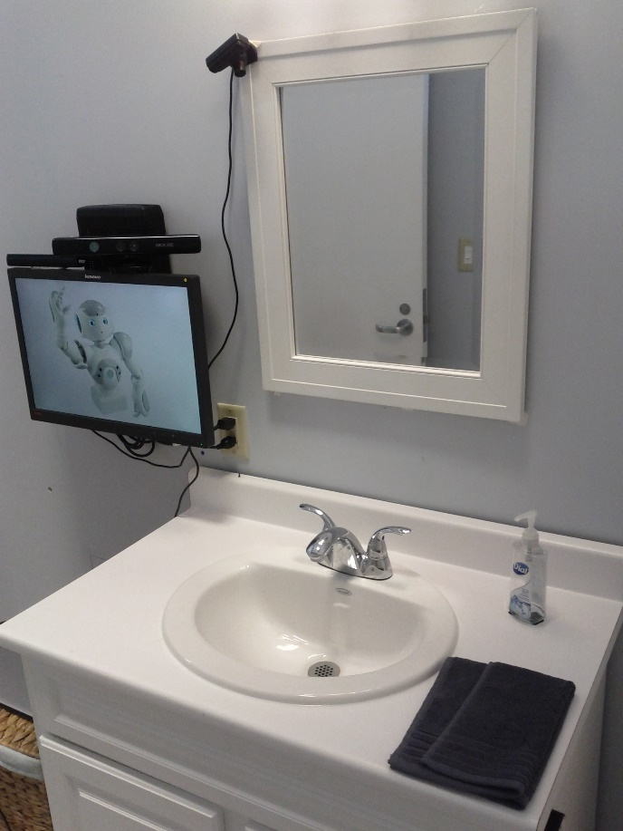

Figure The HomeLab washroom setup with the prompting system: a) with the robot as a prompting agent; b) with the virtual avatar as a prompting agent.

c)

b)

a)

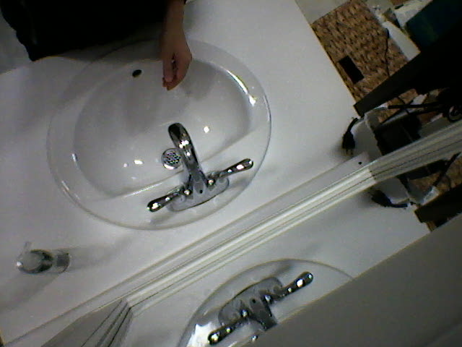 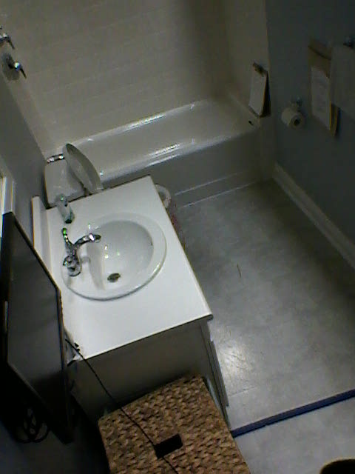 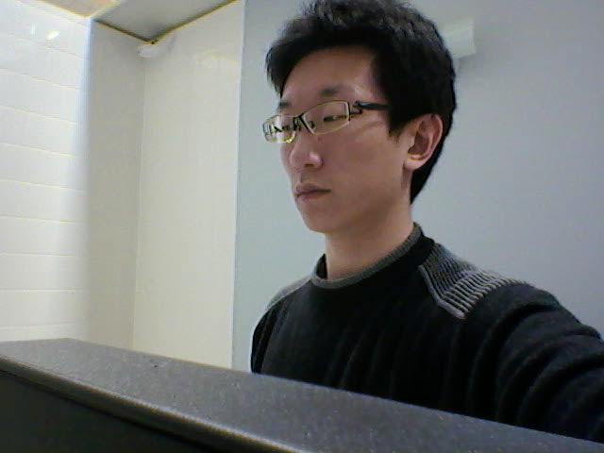

Figure Example images of the camera views - a) overhead camera, b) scene camera, c) Kinect camera.

The Wizard of Oz Experiment

The Wizard of Oz method is an effective technique in Human Computer Interaction (HCI) studies where an interactive agent, which is not yet fully autonomous, is remotely controlled by a human wizard. The wizard may be tasked to control one or many parts of the agent, such as speech recognition and understanding, affect recognition, dialogue management, utterance and gesture generation and so on [12].

This pilot study will follow a Wizard of Oz design. During each session, the child will be asked to complete the hand-washing activity in the washroom with the supervision of one of his/her parents, with the help of the NAO robot, or with the help of the virtual avatar that is displayed on the LCD screen. The student researcher and the parent will be in an adjacent room out of the view of the child when he/she is assisted either by the robot or by the virtual avatar to observe his/her hand-washing activity. An interface (i.e. a touchscreen tablet connecting wirelessly to the mini-computer) will be used by the student researcher to control the robot and the virtual avatar, as well as to monitor the progress and engagement of the child through the video feeds from the overhead and scene cameras that are installed in the washroom.

Study Procedures

Participants will be given a package of consent/assent forms prior to starting the study (please see Appendices F to J). One of the parents will need to provide their consent for their child and themselves to participate in the study. In addition, child participants will need to provide their assent to participate.

Prior to their first HomeLab visit, the parent will also be asked to complete the Social Responsiveness Scale (SRS). The SRS is a commonly used tool to identify the presence and estimate the severity of ASD [13]. The results of the SRS will allow the research team to substantiate a diagnosis of an ASD for the child participants before proceeding with the study. If the child meets the SRS score, the same parent will also be asked to complete the entrance survey before their first visit of the HomeLab. This is to capture the child’s demographics, his/her hand-washing ability level and to gather information to help the research team configure the system to the child’s preferences (please see Appendix A). The same parent who has completed the entrance survey should accompany the child through all the HomeLab visits. Both the SRS and the entrance survey will be conducted by the student researcher.

Each child will visit the HomeLab once a week with a total of six visits with his/her parent. The six visits will be evenly divided into three phases. The three phases are the baseline phase (Phase A) and the intervention phases (Phase B and Phase C). In Phase A, the child will be asked to wash hands by him/herself as independently as possible. The parent will be instructed to provide assistance to the child only when necessary (as outlined below). In Phase B, the child will be assisted by the physical robot during the hand washing. In Phase C, the child will be assisted by the virtual avatar. During each of the intervention trials the parent will be told by the student researcher when to enter to provide assistance to the child, and will be instructed to provide assistance only for the specific step that the child is having difficulties with (as outlined below). Each child will be randomly assigned to one of the two phase orders A-A-B-B-C-C or A-A-C-C-B-B.

It will take about an hour to an hour and a half for each visit. The child will be asked to wash his/her hands eight times for every visit, for a total of forty-eight trials per child. The child and his/her parent may take a fifteen-minute break after the fourth hand-washing activity to prevent fatigue.

The specific protocol for each hand-washing session is as follows:

The hand-washing activity will be broken down into seven tasks: turn on the water, wet your hands, squeeze out the soap, scrub your hands, rinse your hands, turn off the water, and dry your hands. These tasks are modified based on Bimbrahw et al. pilot study [8]. These constitute the same tasks as Bimbrahw’s except that the first (i.e. turn on the water and wet your hands) and the last task (i.e. turn off the water and dry your hands) are now four individual tasks to ensure that each task only involves one action.

All phases will be video recorded by the overhead, the scene, and the Kinect cameras and will be voice recorded by the microphone from the overhead camera. The student researcher will be in the room adjacent to the washroom out of view of the child for all phases. He will remotely control the robot and the virtual avatar in the intervention phases. The parent will be with the child in the washroom for the baseline phase, and will be with the student researcher for the Intervention Phases unless the child needs physical assistance from the parent.

*Phase A (Baseline Phase)*

The first two visits will be the baseline phase and will include sixteen trials of hand washing with eight trials for each visit. The child will be asked to complete the hand-washing as independently as possible. During this phase, the parent will be present in the washroom while the child is completing the hand-washing tasks. The parent will verbally and/or physically assist and give reinforcement to the child whenever the parent feels necessary.

*Phases B and C (Intervention Phases)*

The rest of the four visits will be the intervention phases and will include thirty-two trials of hand washing with eight trials for each visit. The child will be asked to wash his/her hands alone in the washroom. For each task of the hand-washing, if the child does not start a task in 10 seconds, either the NAO robot or the virtual avatar will start interacting with the child and will provide appropriate prompt that is needed to complete the task. The same prompt will be provided again if the child fails to respond to the first one in 10 seconds. If the child fails to respond to the second prompt in 10 seconds, the parent will be called into the washroom to help the child through that task. Also, if the child starts the task but does not complete the task in one minute after starting, the parent will also be called in for assistance. After assistance, the parent will then instruct and encourage the child to continue to finish the rest of the hand-washing tasks on his/her own. The child will be rewarded by either the robot or the virtual avatar if he/she completes a task without parent’ assistance.

There are three steps that the NAO robot and the virtual avatar will follow when interacting with the child (please see Table 1 for the specifics of each prompt used):

1. **First, to catch the child’s attention to the robot or the avatar:**A verbal prompt will be delivered, such as “Hi, [child’s name]!” Synchronous to the verbal, a visual prompt will also be delivered. This is an attention grabbing gesture of waving and looking at the child. If the child does not respond to the prompt in 10 seconds, the same prompt will be given again. There will be a maximum of two attention grabbers given to the child in order to get his/her attention to look at the robot/avatar. The parent will be asked to help the child look at the robot/avatar if he/she does not respond to the second attention grabber.
2. **Second, to prompt the child through a hand-washing task:**A verbal prompt will be delivered, such as “Please [task name]” (e.g. “Please turn on the water.”). Synchronous to the verbal, a visual prompt will also be delivered. This is a two-part gesture prompt of: first, demonstrating motion of interaction while looking at the child; second, pointing to the sink object, such as the tap, while looking at the object. Again a maximum of two prompts will be given to the child. If the child does not respond to the second prompt or starts but does not complete the task in one minute after starting, the parent will be asked to come in and help the child complete the task.
3. **Third, to reward the child when attempting a task without the help from his/her parent:**A verbal reward will be delivered, such as “Yay, good job, [child’s name]!” Synchronous to the verbal, a visual prompt will also be delivered. This is a celebration gesture of raising both hands in the air while looking at the child and flashing the light-emitting diodes (LEDs) on the eyes.

Table Prompt specifications - attention grabber, task prompts, and reward.

|  |  |  |
| --- | --- | --- |
|  | **Verbal Prompt** | **Visual Prompt** (robot/avatar gestures) |
| **Attention Grabber:** | Hi, [child’s name]! | Waving and looking at the child. |
| **Task Prompts:** | Please turn on the water. | Turn right wrist clockwise and look at the child, then point and look at the tap. |
| Please wet your hands. | Hold out hands and look at the child, then point and look at the running water. |
| Please squeeze out the soap. | Right hand presses down and left hand collects from below and look at the child, then point and look at the soap. |
| Please scrub your hands. | Scrub both hands and look at the child, then point and look at the child’s hands. |
| Please rinse your hands. | Hold out hands and look at the child, then point and look at the running water. |
| Please turn off the water. | Turn right wrist counterclockwise and look at the child, then point and look at the tap. |
| Please dry your hands. | Wipes one hand against the other and look at the child, then point and look at the towel. |
| **Reward:** | Good job, [child’s name]! | Raise both hands in the air, flash multicolor LEDs on the eyes, and look at the child. |

During the last visit, the same parent who has completed the entrance survey will be asked to fill out the post-intervention survey and the exit survey (please see appendices B and D), which will allow him/her to provide the research team with his/her feedback regarding the device. A variation of the post-intervention survey will be verbally administered by the student researcher to the child participant to capture his or her views of the system (see Appendix C). This information will be used by the research team to better understand which aspects of the system are effective, which are not, and how, if in any way, the system should be changed.

### Participants

Participants will be recruited through newsletters and/or advertising through the Geneva Centre for (please see Appendix E research study flyer). Participants may also be recruited from the previous autism study who indicated that they would be interested in participating in future studies related to the development of the COACH prompting system.

Participants will be children between the ages of 4 to 15 with a diagnosis of ASD, and their parent. Six children will be recruited. This sample size is typical for studies of this nature for children with ASD. For example, a pilot study by Bimbrahw et al. [8] and a Wizard of Oz study by Bhargava et al. [12] both involved a similar sample size of the children with ASD in their studies. We chose six children for this pilot study in order to equally explore the two permutations of experimental conditions (i.e. A-A-B-B-C-C and A-A-C-C-B-B). Participant demographics will be recorded and will include age, sex, and SRS test results.

The inclusion criteria for enrolment in the study are as follows:

Inclusion criteria:

* Boys and girls between the ages of 4-15
* Parent report of a clinical diagnosis of an ASD – to be confirmed through administration of the Social Responsiveness Scale (SRS)
* Has difficulty independently completing self-care activities, specifically hand-washing
* Has the ability to follow simple, one-step verbal instructions
* Ethical consent granted by parents or primary guardian
* Does not exhibit severely aggressive behavior

Participants will be given a $200 honorarium for completion of the study. All participants will be able to opt out of the study at any time. The honorarium will only be given to participants who complete the whole study, which will be made clear to participants at the time of consent.

### Data Analysis

Three kinds of video data will be collected from the three corresponding cameras – overhead, scene, and Kinect. The overhead and scene video data will be reviewed and annotated by two researchers. The inter-rater reliability will be calculated using Cohen’s Kappa [14]. The overhead video data will be used to score the participants’ prompt compliance and hand-washing performance. The scene video data will be used to evaluate the participants’ engagement during the whole activity. The effect of embodiment on engagement, compliance, and performance will then be explored qualitatively and quantitatively. C-statistic will be used for quantitative analysis [15]. Visual analysis of level changes, slopes, and spread around slopes will be used for qualitative analysis [16]. A statistician may be consulted to determine the best approach to data analysis.

Audio data will also be recorded from the overhead camera. This data will be used for determining the kinds of prompts the parent uses during all phases and for determining the kinds of verbal interactions the child initiates towards the robot or virtual avatar during the intervention phases.

The Kinect video data will not be annotated. Instead, it will be used to evaluate the automatic gaze estimation algorithm that we developed. Specifically, the Kinect video data will be used by the gaze estimation algorithm as input and the output predictions will be compared with annotations of the scene video data to derive the algorithm’s prediction accuracy.

For the survey data, descriptive statistics, such as the mean, minimum, maximum, and standard deviation functions, will be used to assess parents’ attitudes towards the socially assistive humanoid robot. Also, non-parametric analysis will be used to compare parent’s perceived change in the child’s hand-washing ability between the baseline phase and the intervention phases. Exact statistical analysis methodology will be determined after the data collection.

### Dissemination

Results from this research will be published in a journal paper and/or presented at conference(s). Upon completion of the study, participants will be given the option to provide their email or mailing address if they wish to be sent a copy of the resulting publication(s).

### Informed Consent and Confidentiality

Interested families will receive an information/consent package (please see Appendices F to J) prior to starting of the study. This package includes consent/assent forms for participation in the study for the parent and child with ASD (these forms include study details and research contact information) as well as consent to be videotaped for the parent and child with ASD. Consent from the parent and assent from the child with ASD will be given if and when they feel comfortable that they understand the information presented. Potential participants of both parents and children will have up to a week to decide if they would like to participate, although they may consent to participate as soon as they feel comfortable doing so. Parents will need to provide their consent for their children (please see Appendix F) and themselves (please see Appendix G) to participate in the study. In addition, child participants will need to provide their assent (please see Appendix H) to participate. Parents will be required to consent to having their children and themselves videotaped during the study (please see Appendices I and J). The parents will be informed that they and their children may withdraw from the study at any time without penalty.

Each participating family (parent and child with ASD pair) will be assigned a code number when they sign the consent/assent. All data in the study will be labelled with these code numbers only - the names of the participants will appear only on the information and consent/assent forms and will be kept confidential. Consent forms will be placed in a secure and locked area in the PI’s laboratory, with access exclusively restricted to the research team. All forms will be destroyed seven years after the study publication.

# Risks and benefits

There are no known risks associated with this study. The device being tested through this research is non-evasive; there are no safety concerns associated with the use of the prompting system. The small humanoid robot in close proximity with the children is remotely controlled and tightly monitored by the student researcher to prevent physical contact with the children and to prevent it from moving if the children initiate physical contacts. An emergency stop button implemented in the controlling software of the interface is available to instantly disable all motor forces when needed.

Child participants may experience an (temporary or permanent) improvement in hand-washing performance. Findings from the study could guide future development of an automated prompting system for children with ASD.

# Privacy and confidentiality

The information and data collected will remain strictly confidential and will not affect any of the participants (both the parent and the child)’ employment, care, or treatment in any way. A code number will be assigned to each parent and child participant when they give consent. This code number, instead of their name, will be used for all data collection and analysis. Direct quotes may be included in the final research paper but names will not be used in any report or publication. Privacy of participants (both the parents and the children) will be ensured by omitting all participant information from participant data, by employing data encryption, and by storing data on a secure server. If and only if participants consent, participants (both the parents and the children) video data may be presented for educational purposes.

Both the video and audio data will be stored temporarily on the mini-computer’s hard drive during each child’s visit. The data will be encrypted and transferred to the TRI servers as soon as after each child’s visit. The portable devices, such as USB sticks, will be used to transfer the data to the TRI servers. All files stored in the portable devices will be password protected and encrypted. The data on the computer’s hard drive and the portable devices will then be purged immediately after transfer.

All soft (electronic) data will be encrypted before any transfer is made. All data will be password protected and be stored on the TRI servers with access restricted to the research team. The mini-computer used for the study will be password protected so that only the research team has the access to it. All computerized data will be password protected. All survey data will be stored in a locked cabinet different from where the consent forms are stored. Access to all the data will be restricted only to the supervisor and researchers involved in the project.

After the study is completed and the results of the study are published, data will be stored for at least seven years. All data will be destroyed seven years after the study publication. Data contained on paper material will be destroyed by shredding the material. Data contained on electronic media will be destroyed by erasing or other removing the data in such a way that it cannot be retrieved.

# Future Work

This study will provide invaluable information to guide future development of a socially assistive humanoid helping children with ASD in the performance of self-care activities. Such a device would be helpful not only to the children, but also to their families and caregivers, as the device would promote independence for the children and assist family members and caregivers with caring for their children, helping to improve sense of well-being and quality of life for both.

# References

[1] R. J. Landa, "Diagnosis of autism spectrum disorders in the first 3 years of life," *Nature Clinical Practice Neurology,* vol. 4, pp. 138-147, 2008.

[2] F. R. Volkmar, R. Paul, A. Klin, and D. J. Cohen, *Handbook of Autism and Pervasive Developmental Disorders, Diagnosis, Development, Neurobiology, and Behavior* vol. 1: John Wiley & Sons, 2005.

[3] P. T. Leff and E. H. Walizer, "The uncommon wisdom of parents at the moment of diagnosis," *Family Systems Medicine,* vol. 10, p. 147, 1992.

[4] D. E. Carothers and R. L. Taylor, "How teachers and parents can work together to teach daily living skills to children with autism," *Focus on autism and other developmental disabilities,* vol. 19, pp. 102-104, 2004.

[5] G. S. MacDuff, P. J. Krantz, and L. E. McClannahan, "Teaching children with autism to use photographic activity schedules: Maintenance and generalization of complex response chains," *Journal of Applied Behavior Analysis,* vol. 26, pp. 89-97, 1993.

[6] T. Van Laarhoven, E. Kraus, K. Karpman, R. Nizzi, and J. Valentino, "A comparison of picture and video prompts to teach daily living skills to individuals with autism," *Focus on Autism and Other Developmental Disabilities,* vol. 25, pp. 195-208, 2010.

[7] A. Mihailidis, J. N. Boger, T. Craig, and J. Hoey, "The COACH prompting system to assist older adults with dementia through handwashing: An efficacy study," *BMC geriatrics,* vol. 8, p. 28, 2008.

[8] J. Bimbrahw, J. Boger, and A. Mihailidis, "Investigating the Efficacy of a Computerized Prompting Device to Assist Children with Autism Spectrum Disorder with Activities of Daily Living," *Assistive Technology,* vol. 24, pp. 286-298, 2012.

[9] K. Dautenhahn and I. Werry, "Towards interactive robots in autism therapy: Background, motivation and challenges," *Pragmatics & Cognition,* vol. 12, pp. 1-35, 2004.

[10] A. Duquette, F. Michaud, and H. Mercier, "Exploring the use of a mobile robot as an imitation agent with children with low-functioning autism," *Autonomous Robots,* vol. 24, pp. 147-157, 2008.

[11] A. Wong, Y. K. Tan, A. Tay, A. Wong, D. K. Limbu, T. A. Dung*, et al.*, "A user trial study to understand play behaviors of autistic children using a social robot," in *Social Robotics*, ed: Springer, 2012, pp. 76-85.

[12] S. Bhargava, S. Janarthanam, H. Hastie, A. Deshmukh, R. Aylett, L. Corrigan*, et al.*, "Demonstration of the Emote Wizard of Oz Interface for Empathic Robotic Tutors," in *Proceedings of SIGdial*, 2013.

[13] J. N. Constantino and C. P. Gruber, "The social responsiveness scale," *Los Angeles: Western Psychological Services,* 2002.

[14] J. Wainer, D. J. Feil-Seifer, D. A. Shell, and M. J. Mataric, "Embodiment and human-robot interaction: A task-based perspective," in *Robot and Human interactive Communication, 2007. RO-MAN 2007. The 16th IEEE International Symposium on*, 2007, pp. 872-877.

[15] W. W. Tryon, "A simplified time‐series analysis for evaluating treatment interventions," *Journal of applied behavior analysis,* vol. 15, pp. 423-429, 1982.

[16] S. Z. Ottenbacher, Kenneth J, "Single subject research designs for disability research," *Disability & Rehabilitation,* vol. 23, pp. 1-8, 2001.

# List of Appendices

Appendix A: Entrance Survey

Appendix B: Post-Intervention Survey for Parent

Appendix C: Post-Intervention Survey for Child

Appendix D: Exit Survey

Appendix E: Research Study Flyer

Appendix F: Consent Form - Child

Appendix G: Consent Form – Parent

Appendix H: Assent Form - Child

Appendix I: Videotaping Consent Form - Child

Appendix J: Videotaping Consent Form - Parent